HPOA Architect Control Committee
3381 Starboard Drive
May, TX 76857
325-221-3355
Harborpointownersassociation.net harborpoint-ACC.com

Property Alteration Application for Chicken Habitat Construction
Purpose of Application:
To allow for an approved structure to be constructed on owners property for chicken habitat. By signing this application, the owner agrees to all requirements of Restriction 8.
With regard to this application, all HPOA restrictions must be followed.

DO NOT START OR COMMENCE ANY ALTERATIONS TO YOUR PROPERTY
WITHOUT APPROVAL OF THIS APPLICATON.

Date:_____/_____/_____ __________________________________ ________________________
Legal owner name and applicant email address (req’d)

_____________________________________ ____________ ______ __________ ____________________________________ mailing address city st zip code phone

_____________________________________ May, TX. 76857 _____________________
structure address city st zip code Lot number(s)

Any information listed requested on this form that is not provided will delay application approval.

Requirements of Applicant:
- Application should include a detailed location of the structure on the lot and material specifications. Provide details of sewer, power, as applicable to assist the ACC in the approval process.
- Obtain any permits required from county or state.

- Contact Zephyr Water (325-739-5264) prior to digging or excavating.
- Applicant is required to remove all litter / trash related this alteration including removal of any old structures. HPOA dumpsters are not to be used for any construction materials.
- Applicant is responsible or correcting all consequential damages to roads, ditches, easements, or utilities.
- Applicant agrees that any deviation from the subdivision restrictions or this application, once approved, will invalidate the approval.

Description of requested alteration:____________________________________________________________
__________________________________________________________________________________________
__________________________________________________________________________________________
__________________________________________________________________________________________
__________________________________________________________________________________________
__________________________________________________________________________________________

Use additional pages to illustrate alteration in accordance with HPOA Restrictions:
Provide top view:
- Indication of north direction
- Streets
- Property lines
- Existing structures
- Proposed structure dimensions
- Backset distances from lot lines
- Approx. distance between all structures

Illustration of your proposed structure.
Example Only. Your pen may vary in footprint. Square foot examples apply to all applicants.
Coop Side View Run / Pen Side View
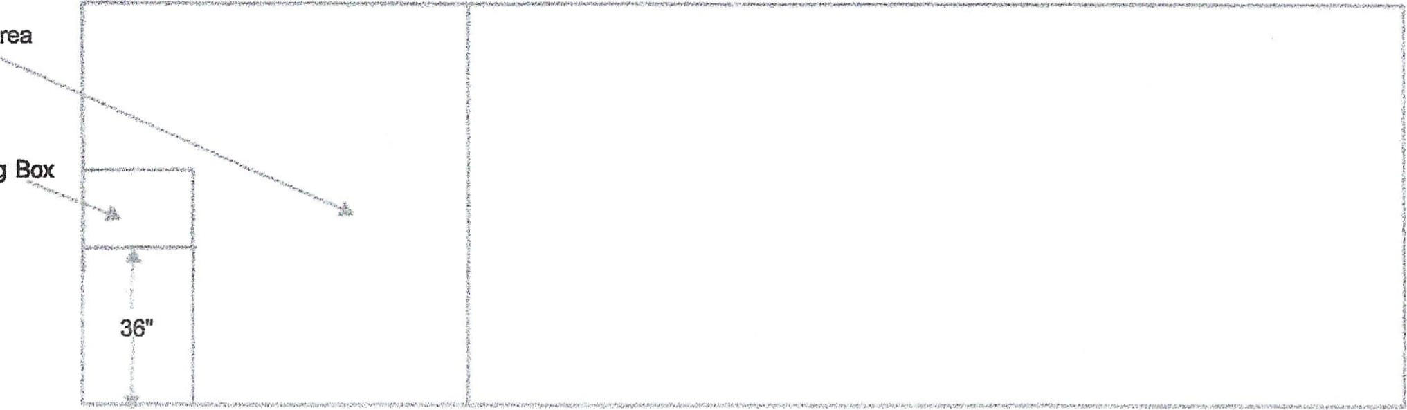
Coop Area
Nesting Box
Top View
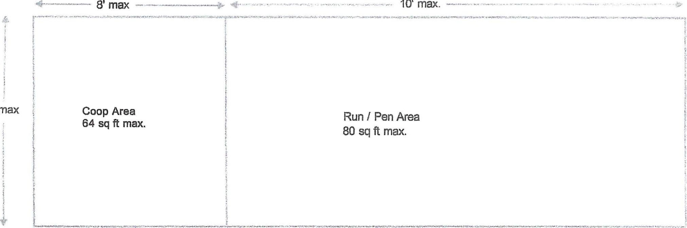
8'
max
Restriction requirements: (Al construction material must be new.)
- Chicken structures restricted to rear of owners lots.
- Structures must be 20' minimum distance from side and rear lot lines 3) Nesting boxes must be a minimum of 36" off the ground.
- Coop maximum of 8' x 8' (64 sq ft max)
- Coop must be completed secured to protect chickens from predators.
- Top of coop must be covered.
- Run / Pen area must be 15 sq ft minimum per bird. Maximum of 20 sq ft per bird.
- 4' high minimum containment fence. (Chickens can fly. Recommend 6' high minimum.

